**taller IEEE**

1. **Rmarkdown**

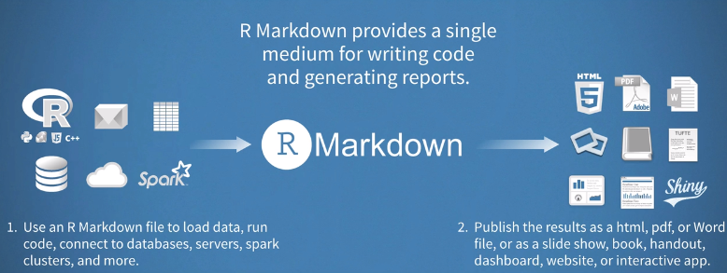

**Write chunks with other languages not only R**

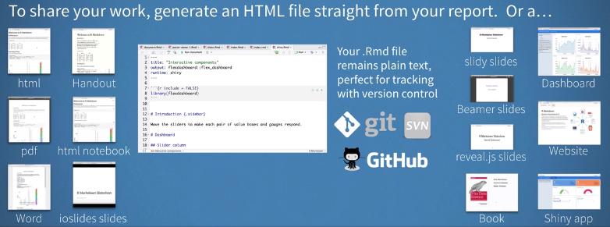

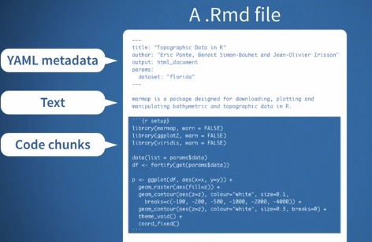

**<https://rstudio.com/wp-content/uploads/2015/03/rmarkdown-spanish.pdf>**

**<https://rmarkdown.rstudio.com/articles_intro.html>**

**[https://rmarkdown.rstudio.com/authoring_quick_tour.html#Installation](https://rmarkdown.rstudio.com/authoring_quick_tour.html" \l "Installation)**

**<https://rmarkdown.rstudio.com/lesson-2.html>**

1. **Shiny Dashboard**
2. **Sitio Web**